# LAB EXPERIMENT 04

# Implementation of Newton Raphson Method using MATLAB

## Objective:

To find the roots of the given function by using Newton Raphson Method through MATLAB

## Theory:

The Newton Raphson method is for solving equations of the form f(x) = 0. We make an initial guess for the root we are trying to find, and we call this initial guess, the sequence generated in the manner described below should converge to the exact root.

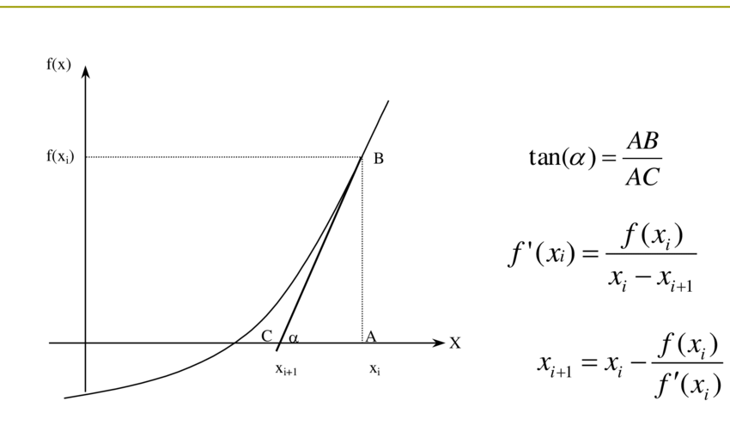

Figure : Geometric Representation of Newton Raphson Method Algorithm

The steps of the Newton-Raphson method to find the root of an equation  are

1. Evaluate  symbolically
2. Use an initial guess of the root, , to estimate the new value of the root, , as



1. Find the absolute relative approximate error  as



Compare the absolute relative approximate error with the pre-specified relative error tolerance, . If >, then go to Step 2, else stop the algorithm. Also, check if the number of iterations has exceeded the maximum number of iterations allowed. If so, one needs to terminate the algorithm and notify the user. (If Error is given)

## Problem Statement:

# Implement Newton Raphson Method on the following function through MATLAB:

# $f\left(x\right)=x^{2}-8x+1$; $x_{i}=1$

## MATLAB Code:

|  |
| --- |
| clc, clear  %% Defining Function and Variables    f = @(x) x.^2 - 8*x + 1  syms x  diff = inline(diff(f,x))    x0 = 1;  xi = x0;  n = 0;  y = 1;    %% Program    fprintf("\n")  if diff(xi) == 0  fprintf("Function has a differentiate of 0 \n")  else  while y ~= 0  if y ~= 0  y = f(xi);  d = diff(xi);  xf = xi - (y/d);  xi = xf;  n = n + 1;  y = round(y,4); %Rounding off correct to 4 decimal points    fprintf("Iterations: %.1f, Root: %.4f, f(x): %.4f, Diff(f(x)): %.4f \n", n, xi, y, d)  else  break  end  end  end    %% Graph Plotting    temp_x = -2:0.01:2;  for i = 1:length(temp_x)  t(i) = f(temp_x(i));  end    plot(temp_x,f(temp_x), 'r--'); hold on;  scatter(xi, y, 'ks');  line([0 0], [-15 25])  line([-2 2], [0 0])  legend('f(x)', 'Root')  xlabel('X Axis')  ylabel('Y Axis')  title('Kamil Siddiqui - Root Finding using Newton Raphson')    annotation("textbox", [0.15, 0.14, 0.3, 0.1], 'String', "The function has a root when it cuts x-axis at y=0")    xt = [0.36 0.3];  yt = [0.8 0.65];  annotation('textarrow', xt, yt, 'String', 'f(x) = x^2 - 8x + 1') |

## Results:

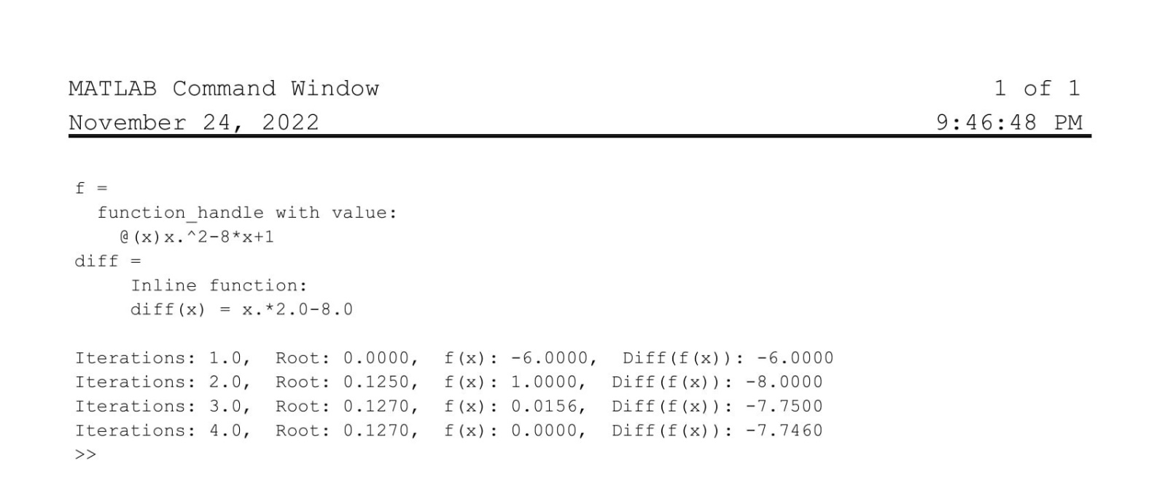

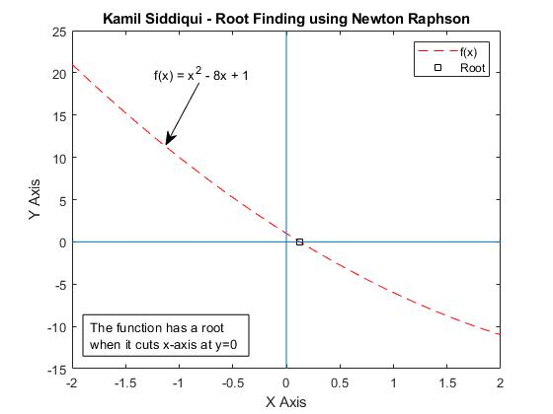

## Discussion:

Comments will be made on the following:

1. If the same Function is solved by other methods (Bisection/False position etc.) then what difference is shown in the approximated root values?

1. Discuss about the advantages of Newton Raphson Method over the other methods

1. Write down the condition in which Newton Raphson Method does not work.